6 D A Y S A F A R I
M A A S A I M A R A-
NAKURU – OL PEJETA
DAY 1
06:00 – 11:00 You will be picked from your hotel in Nairobi after breakfast by our drivers thereafter beginning our journey towards Maasai Mara, home of the Maasai. Maasai Mara is one of the world’s premier animal reserves that boasts of the Great Wildebeest migration, one of the 8 Wonders of the Natural World. The park is bursting with wildlife and here you have a high chance of viewing all of the Big 5 (lions, leopards, buffalo, elephant and the elusive rhino). The Park is also famous for its numerous heard of gnu/wildebeest, zebra and other grazers, as well as cheetah and hyena.
The drive to Mara will be approximately 4.5 to 5 hour drive and on the way you will have a short break at the Great Rift Valley viewpoint where you shall enjoy a spectacular views of the Great Rift Valley.
11:00 – 12:00 You will be arriving at Maasai Mara National Reserve and after formalities at the park entry gate, proceed to your tented safari camp where you shall check – in and proceed to enjoy lunch. Afternoons in the African savannah are extremely hot, so the afternoon shall be spent relaxing and getting away from the heat.
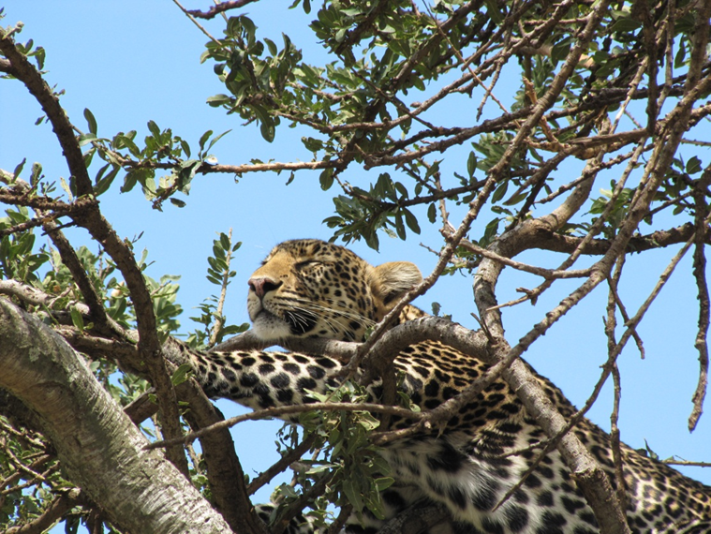

16:00 – 18:30 At this time, we leave for an evening game drive. The day is getting cooler and animals are coming out from their hiding and are more active. This is excellent time for game viewing and taking photos for those who like to capture the memories on film.
18:30 onwards You will be driven back to your camp for an evening of relaxation. You shall also enjoy delicious food on the menus and after reminisce of the day’s events while sipping on the cold Tusker beer or your favorite drink. Don’t forget to get some good night rest to be ready for your next day.
DAY 2
06:30 – 08:30 The whole of day to will be spent in the Maasai Mara National reserve. Early Morning game drives are highly recommended as you get to see the nocturnal animals before they retreat to their den’s, mostly lions and hyenas. It is also excellent time to take photos as the light is always just right plus you get to see the breathtaking African sunrise.
08:30 – 10:30 You will have got back to your camp and you will have a nice warm breakfast. You will then have time to get back to your room to freshen up, get some rest and prepare for another mid - morning game drive.
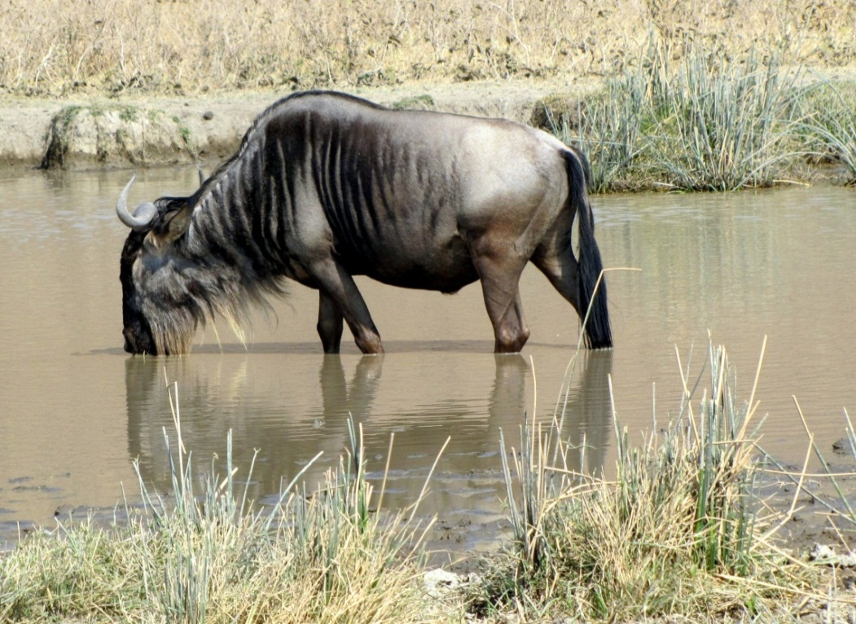
10:30 – 12:30 Game drive enjoying spectacular views and the abundance of animals that the Maasai Mara Game Reserve is so famous for. The drivers who are at your service will be able to share with you all the knowledge they have about the wildlife and their environment as well as try to find whatever animal that you might have not seen up to that time. Please feel free ask him for any information or questions that you may have throughout your safari and we are sure they will be more than happy to respond to them.
12:30 – 16:00 After getting back from your mid – morning game drive, a hot lunch will be waiting for you and the camp staff shall let you know when they will be ready to serve you. It’s getting very hot as well around this time, so we will allow you to retreat back to your tent after lunch, or enjoy a cold beverage under the shade while we wait for the temperatures to drop and go out again for the evening drive.
16:00 – 18:30 You start your evening game drive, again trying to spot the predators as they head out after the hot day in search for their next meal. Slowly, the driver shall take you round at a leisurely pace to ensure you get the most out of this last game drive after which he shall take you back to your camp for the evening meal and last night in Maasai Mara National reserve. Keep listening for the deep lion roars in the night or the creepy hyena laugh in the dark. The noises in the African bush are exciting and bone-chilling as well and this all adds up to the experience. Remember to look up as well for the gorgeous display of the cosmos, the African sky in the night is nothing like you have seen before.
DAY 3
06:00 – 07:00 You will wake up, pack your luggage bring it out to the reception on your way out to breakfast and to check out of the camp. After breakfast and checking out of the camp, the drivers who will have loaded your luggage in the car already will then proceed to take you to your next destination which will be about a 5hrs drive away.
07:00 – 12:00 Drive to Lake Nakuru National Park. Approximately 45sq. km, Lake Nakuru is the home of Flamingoes and the park boasts of 54 different species of animals and over 400 species of birds. It also boasts one of the largest herds of black and white rhinos in Kenya. Once you are in the park, you shall proceed to your lodge where you shall check in and have lunch. After lunch, we will allow you some time to enjoy your lodge and rest before our next game drive which will be later on in the evening.
16:00 – 18:30 You will be taken out for your first game drive in Nakuru National Park. Highlights will be spotting of black and white rhino in the wild. The magnificent beasts are extremely rare to see and Lake Nakuru National Park offers you that chance. Flamingoes and the wide variety of birds as well as the usual suspects, the Big 5 and the other African cats and predators will definitely pop up every now and then to make this experience even more rewarding. This evening game drive will be until just before dark when you will be take back to your lodge.
18:30 – Onwards You have dinner at the lodge and after that you can enjoy drinks in this beautiful lodge’s terrace. Hopefully this time will be well spent discussing the amazing day that you just had and hopefully you will be looking forward to the next day.

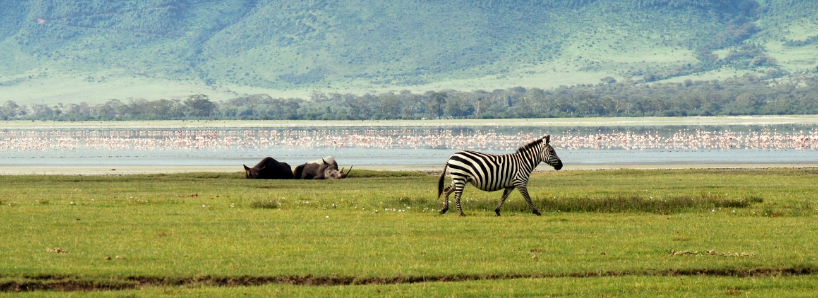

DAY 4
06:30 – 08:30 You shall be taken for an early morning game drive, and you shall hopefully be able to see the ‘night stalkers’ before they retreat to their daylight hide-outs. You shall also have the pleasure of enjoying the beautiful sunrise in the morning as you get along the game drive.
08:30 -09:30 After the game drive, you shall proceed back to the lodge for breakfast. We shall then check out of the lodge and load the luggage to the vans ready to head to our last destination.
09:30 – 12:30 You will be driven to Ol Pejeta Conservancy in Laikipia, also known as Sweetwaters Game Reserve. Ol Pejeta Conservancy is East Africa’s largest Black Rhino Sanctuary, the only place in Kenya you can see Chimpanzees and hold some of the highest predator densities in Kenya. African wild dogs, spotted hyenas, leopards, bat-eared fox and cheetahs and present as well as the rest of the big 5, all in 350sq. km of African bush.
12:30-16:00 After arriving in Ol Pejeta Conservancy, you will check in to your camp and have a hot lunch. You will then be given the opportunity to familiarize yourself with the conservancy and learn what the conservancy has to offer. This time can also be used for relaxation or an afternoon siesta if you so please.
16:00-18:30 You shall be taken out the magnificent place to see what it has to offer you. Wildlife is in plenty. Our driver will carefully take you through your game drive, making sure you enjoy every single minute of your time in the conservancy. Enjoy the beautiful views and later on as the day winds down, a spectacular African sunset in the wild.
18:30 – Onwards Dinner and overnight at the camp.
DAY 5
06:30 – 08:30 Early morning game drive. The early morning drive offers you the chance to spot the night hunters either trying to catch a last meal before the full blare of the sun, or just about the go into hiding away from the sun. This is our last day of the safari so make sure you use the remaining space in your camera when you are out there.
08:30 – 09:30 Breakfast back at the camp and you can go and freshen up and relax in the camp.
09:30 – 12:30 We will take this time to take you the Ol Pejeta Chimpanzee Sanctuary, the only one in Kenya where you can see these amazing apes. The work they are doing is amazing and you can interact with the staff of the project and ask questions about the animals. There is also options of visiting the White Rhino sanctuary at an extra cost, participate in guided bush walks, visit schools and community projects, livestock and wildlife integration.
12:30 – 16:00 Back to the camp for lunch and after, you can either decide to rest and enjoy a cold beverage or siesta in the afternoon, or maybe do other activities mention above if you are interested to do them. This has be decided before hand in order to allow time to book and arrange for it.
1600 – 1800 Evening game drive. By this time we believe you will be experts in spotting wildlife and even recognizing and remembering their names. Still, you could be surprised by the African wilderness by seeing something that you had not seen before, or seeing some wildlife in action (maybe a lion hunt!). It’s still very pleasant and satisfying to be out there and enjoying the safari, even if just the magnificent views and of course, the very colorful African sunset.
18:00 – Onwards After the evening drive, we retreat back to the camp for our evening refreshments, dinner and overnight stay. There is availability of night game drives in Ol Pejeta Conservancy, and those interested can let us know in advance so that arrangements can be made for you. You will be going out in the night with big flash lights looking for the animals that are mostly active in the night. Lions and hyenas are the main characters in this play but so many others also take part. This will be available from 19:00 – 23:00 so make sure you have had your dinner and taken some appropriate clothing for this activity.
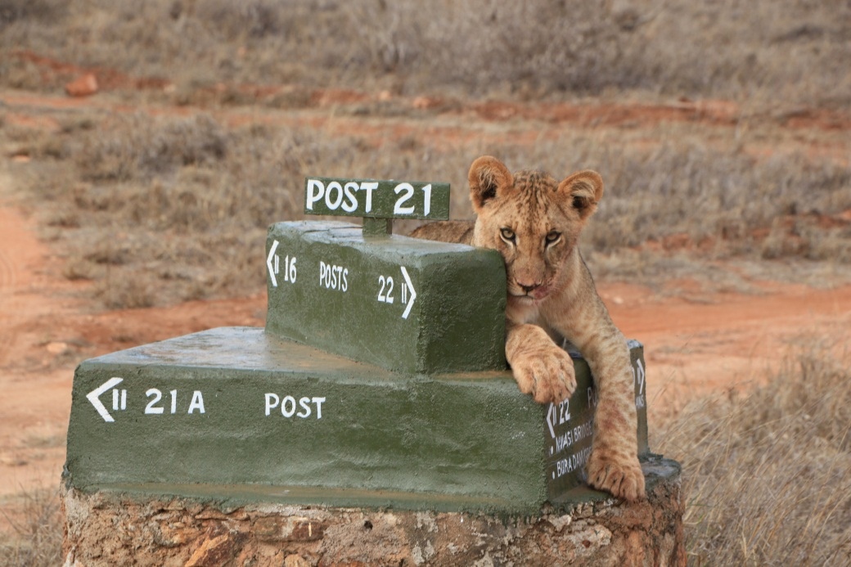

DAY 6
06:30 – 08:30 Last game drive in Ol Pejeta whereby you will the taken out to enjoy the morning beauty of Ol Pejeta Conservancy. Perhaps a last glimpse of a lion, cheetah, leopard or hyena will do it for you. Perhaps elephants grazing in the morning sunlight or gazelles or zebras, this will be a very relaxed game drive to ensure you have the most pleasant time. After that, you shall be taken back to the camp for a hot breakfast.
08:30-10:00 Between this time, you are expected to have your breakfast, pack your luggage and check out from your tent. The driver will also load the luggage in the van and prepare for the journey to our final park in our program.
10:00 – 13:00 We shall aim to depart from Ol Pejeta Conservancy at this time and head for Samburu National Park which is 150km away and will take about 3hrs to reach. Samburu National Reserve is in what is known as the Kenya Northern Frontier District. It covers an area of about 104sq. km and rises to an altitude of 2,785 feet above sea level. It is home to the rare Gravy Zebra, Reticulated Giraffe, Besia Oryx, Greater and Lesser Kudu, Gerenuk, Somali ostrich, pancake tortoise which is endangered as well as the usual suspects (big cats, elephants, buffaloes hyena etc.) The Park has only one water source, river Ewaso Ngiro which teems with crocodiles and hippos. A vast number of bird species are also present. It has hot and dry climate with mainly wooded and bushy grassland, riverine forest and swamps.
13:00 – 16:00 You will arrive to your lodge, check in and have a hot lunch, we shall then allow you to relax and familiarize yourself and enjoy the lodge and its surroundings. This is because it gets very hot during the day and the animals tend to hide away from the heat. A cold beer or a siesta would not be such a bad idea while you wait to go for your evening game drive.
16:00 – 18:30 Experience your first game drive in Samburu. The vegetation, climate and atmosphere are very different from the other areas. This is the Kenya Northern Frontier District, pure rugged African bush. You shall be hoping to see the animals that are only specific or particular to this park like the Grevy Zebra, Reticulated giraffe, Besia Oryx, Greater and Lesser Kudu, Gerenuk, Somali ostrich, pancake tortoise, Aardwolf and striped hyena.
18:30 – Onwards You will return back to your lodge for the night which will include a sumptuous dinner. Enjoy the evening and the comfort that the lodge will provide you. Remember to have a good night rest to recharge the batteries well for the next day.
DAY 7
06:30 – 08:30 The whole day will be spent in Samburu National Reserve. You will start the day by having a hot tea/coffee that will be provided to you by the lodge then after you will proceed for the early morning game drive. Rare nocturnal animals have been wondering in the night and this is the chance to get a glimpse of them before they head back to their daytime hideouts. You will be looking driving and enjoying the views as well as the sunrise in Samburu until 0830 when you will go back to the lodge. A warm breakfast will be waiting for you and after which you will have some time before we head back out for our mid-morning game drive to have a shower or refresh yourself.
10:00 – 12:30 You will be taken out for a game drive to sample more of what Samburu has to offer. Your driver who is also an experience guide, will share all the knowledge that he has about all the wildlife that you will see. Feel free to ask him any questions that you might have regarding the animals or just general topics about Kenya.
12:30 – 16:00 After you get back from the game drive, lunch will be served. The afternoon gets very hot in Samburu and there is not many animals you will see because they all seek shelter from the blazing hot sun. Take this time to relax, enjoy a cold drink (Tusker) or maybe have a siesta as we wait for things to cool down.
16:00 – 18:30 Head out for the evening game drive when animals are more active as the result of cooler temperatures. Chances of seeing some cats are high as well as nocturnal animals coming out in search of their next meal. Let’s see who will find one first! You will be out until the sunset, which we promise will be spectacular because the African sunsets rarely do disappoint.
18:30 – onwards Just after the sun sets, you will be driven back to the lodge for dinner and the last night on our program. We do hope by this time that you have seen all that is out there to see, and that you shall sleep well and rest your tired body.
DAY 8
06:30 – 08:00 This is our last day on the program and we shall be taking it easy. No early morning game drive. You will after getting a warm shower and breakfast, proceed to check out of your room and handing your luggage over to the driver who will load it to the van. Be sure you have all your belonging with you when leaving your room and make sure you have cleared all your bills.
08:00 – 13:00 We shall be driving through the park on our way out and back to Nairobi. This shall be kind of the ‘last’ game drive as sometimes the lucky ones see something as they head out. The journey back to Nairobi will take approximately 5 hours and we aim to have you back in Nairobi in time for lunch. You shall maybe on the way back if you are lucky and there is clear sky, see Mt. Kenya. This is the last part of our program. The driver will drop you and your luggage back at your hotel, or airport in time for lunch or flight back home.

We hope you had aan amazing time with unforgettable memories and we do hope you shall come back to us for more, or tell other about us and our services and let them also come to us for a similar or even more exciting safari.

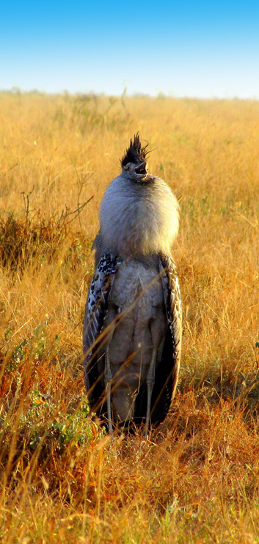
WHAT TO TAKE:

- SUN PROTECTION CREAM
- HAT/CAP
- SUN GLASSES
- ANTI MOSQUITO/INSECT REPELLANT
- COMFORTABLE, LIGHT CLOTHES AND SHOES
- LONG SLEEVE TROUSERS AND JACKET FOR EARLY MORNING AND EVENING DRIVES
- CAMERA
- SPARE BATTERIES
- BINOCULARS

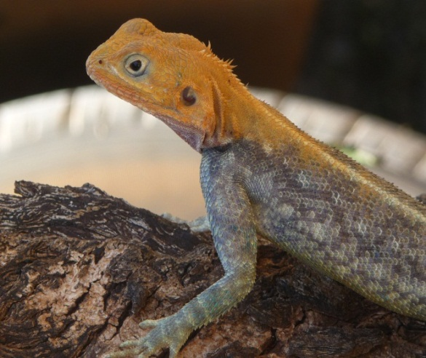
PRICE INCLUDES:
- PARK FEES
- TRANSPORT IN A MINI VAN WITH
A POP-UP ROOF FROM AND BACK TO
THE HOTEL
- DRIVER-GUIDE ASSISTANCE
- WATER IN THE CAR 0,5 L. PER PERSON
- BUFFET LUNCH IN THE HOTEL

info@costotours.com +254 704 135 984

