6 D A Y S A F A R I
M A A S A I M A R A-
NAKURU – OL PEJETA
DAY 1
06:00 - You will be picked from your hotel after breakfast by our drivers thereafter beginning our journey towards Maasai Mara, home of the Maasai. Maasai Mara is one of the world’s premier animal reserves that boasts of the Great Wildebeest migration, one of the 8 Wonders of the Natural World. The park is bursting with wildlife and here you have a high chance of viewing all of the Big 5 (lions, leopards, buffalo, elephant and the elusive rhino). The Park is also famous for its numerous heard of gnu/wildebeest, zebra and other grazers, as well as cheetah and hyena.
The drive to Mara will be approximately 4.5 to 5 hour drive and on the way you will have a short break at the Great Rift Valley viewpoint where you shall enjoy a spectacular views of the Great Rift Valley.
11:00 – 12:00 - You will be arriving at Maasai Mara National Reserve and after formalities at the park entry gate, proceed to your tented safari camp where you shall check – in and proceed to enjoy lunch. Afternoons in the African savannah are extremely hot, so the afternoon shall be spent relaxing and getting away from the heat.
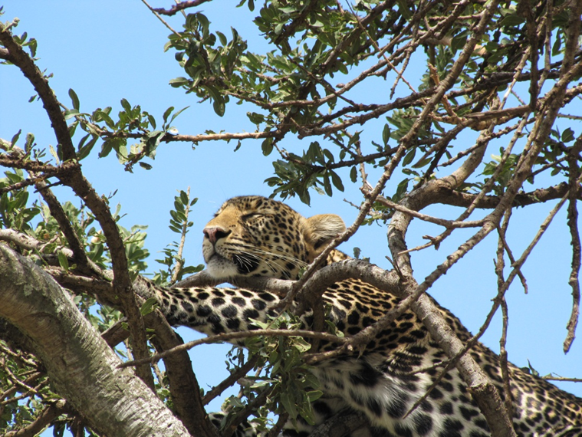

16:00 – 18:30 - At this time, we leave for an evening game drive. The day is getting cooler and animals are coming out from their hiding and are more active. This is excellent time for game viewing and taking photos for those who like to capture the memories on film.
18:30 onwards - You will be driven back to your camp for an evening of relaxation. You shall also enjoy delicious food on the menus and after reminisce of the day’s events while sipping on the cold Tusker beer or your favorite drink. Don’t forget to get some good night rest to be ready for your next day.
DAY 2
06:30 – 08:30 - The whole of day to will be spent in the Maasai Mara National reserve. Early Morning game drives are highly recommended as you get to see the nocturnal animals before they retreat to their den’s, mostly lions and hyenas. It is also excellent time to take photos as the light is always just right plus you get to see the breathtaking African sunrise.
08:30 – 10:30 - You will have got back to your camp and you will have a nice warm breakfast. You will then have time to get back to your room to freshen up, get some rest and prepare for another mid - morning game drive.
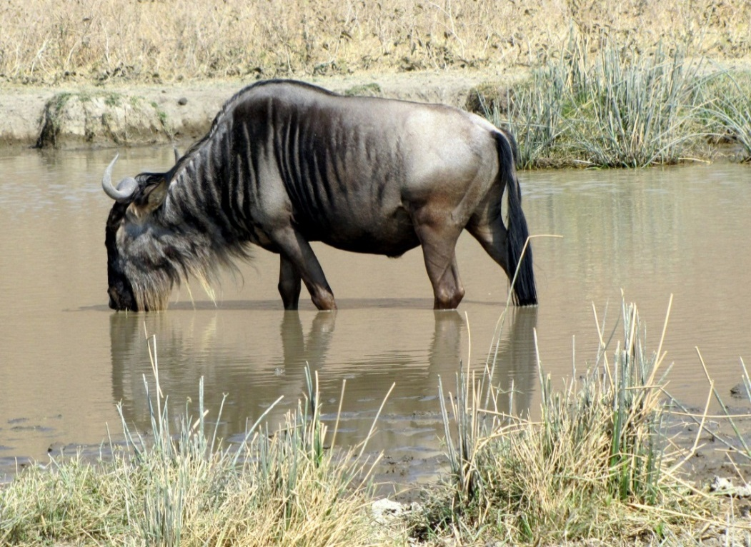
10:30 – 12:30 - Game drive enjoying spectacular views and the abundance of animals that the Maasai Mara Game Reserve is so famous for. The drivers who are at your service will be able to share with you all the knowledge they have about the wildlife and their environment as well as try to find whatever animal that you might have not seen up to that time. Please feel free ask him for any information or questions that you may have throughout your safari and we are sure they will be more than happy to respond to them.
12:30 – 16:00 - After getting back from your mid – morning game drive, a hot lunch will be waiting for you and the camp staff shall let you know when they will be ready to serve you. It’s getting very hot as well around this time, so we will allow you to retreat back to your tent after lunch, or enjoy a cold beverage under the shade while we wait for the temperatures to drop and go out again for the evening drive.
16:00 – 18:30 - You start your evening game drive, again trying to spot the predators as they head out after the hot day in search for their next meal. Slowly, the driver shall take you round at a leisurely pace to ensure you get the most out of this last game drive after which he shall take you back to your camp for the evening meal and last night in Maasai Mara National reserve. Keep listening for the deep lion roars in the night or the creepy hyena laugh in the dark. The noises in the African bush are exciting and bone-chilling as well and this all adds up to the experience. Remember to look up as well for the gorgeous display of the cosmos, the African sky in the night is nothing like you have seen before.
DAY 3
06:00 – 07:00 - You will wake up, pack your luggage bring it out to the reception on your way out to breakfast and to check out of the camp. After breakfast and checking out of the camp, the drivers who will have loaded your luggage in the car already will then proceed to take you to your next destination which will be about a 5hrs drive away.
07:00 – 12:00 - Drive to Lake Nakuru National Park. Approximately 45sq. km, Lake Nakuru is the home of Flamingoes and the park boasts of 54 different species of animals and over 400 species of birds. It also boasts one of the largest herds of black and white rhinos in Kenya. Once you are in the park, you shall proceed to your lodge where you shall check in and have lunch. After lunch, we will allow you some time to enjoy your lodge and rest before our next game drive which will be later on in the evening.
16:00 – 18:30 - You will be taken out for your first game drive in Nakuru National Park. Highlights will be spotting of black and white rhino in the wild. The magnificent beasts are extremely rare to see and Lake Nakuru National Park offers you that chance. Flamingoes and the wide variety of birds as well as the usual suspects, the Big 5 and the other African cats and predators will definitely pop up every now and then to make this experience even more rewarding. This evening game drive will be until just before dark when you will be take back to your lodge.
18:30 – Onwards- You have dinner at the lodge and after that you can enjoy drinks in this beautiful lodge’s terrace. Hopefully this time will be well spent discussing the amazing day that you just had and hopefully you will be looking forward to the next day.

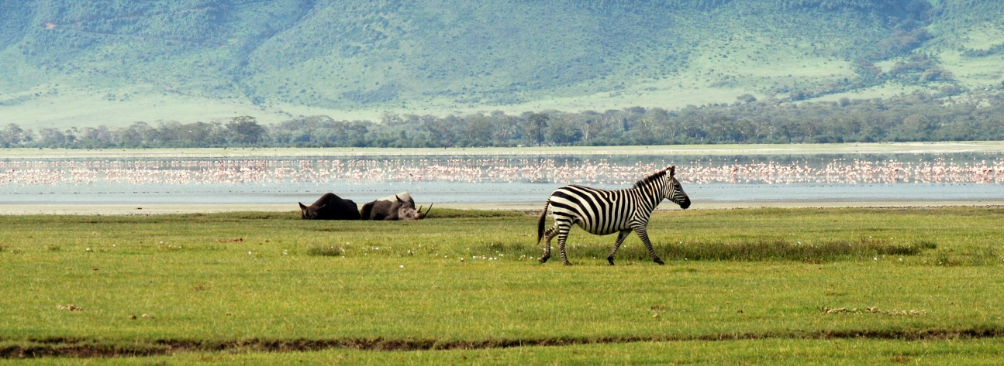

DAY 4
06:30 – 08:30 - You shall be taken for an early morning game drive, and you shall hopefully be able to see the ‘night stalkers’ before they retreat to their daylight hide-outs. You shall also have the pleasure of enjoying the beautiful sunrise in the morning as you get along the game drive.
08:30 -09:30 - After the game drive, you shall proceed back to the lodge for breakfast. We shall then check out of the lodge and load the luggage to the vans ready to head to our last destination.
09:30 – 12:30 - You will be driven to Ol Pejeta Conservancy in Laikipia, also known as Sweetwaters Game Reserve. Ol Pejeta Conservancy is East Africa’s largest Black Rhino Sanctuary, the only place in Kenya you can see Chimpanzees and hold some of the highest predator densities in Kenya. African wild dogs, spotted hyenas, leopards, bat-eared fox and cheetahs and present as well as the rest of the big 5, all in 350sq. km of African bush.
12:30-16:00 - After arriving in Ol Pejeta Conservancy, you will check in to your camp and have a hot lunch. You will then be given the opportunity to familiarize yourself with the conservancy and learn what the conservancy has to offer. This time can also be used for relaxation or an afternoon siesta if you so please.
16:00-18:30- You shall be taken out the magnificent place to see what it has to offer you. Wildlife is in plenty. Our driver will carefully take you through your game drive, making sure you enjoy every single minute of your time in the conservancy. Enjoy the beautiful views and later on as the day winds down, a spectacular African sunset in the wild.
18:30 – Onwards - Dinner and overnight at the camp.
DAY 5
06:30 – 08:30 - Early morning game drive. The early morning drive offers you the chance to spot the night hunters either trying to catch a last meal before the full blare of the sun, or just about the go into hiding away from the sun. This is our last day of the safari so make sure you use the remaining space in your camera when you are out there.
08:30 – 09:30 - Breakfast back at the camp and you can go and freshen up and relax in the camp.
09:30 – 12:30 - We will take this time to take you the Ol Pejeta Chimpanzee Sanctuary, the only one in Kenya where you can see these amazing apes. The work they are doing is amazing and you can interact with the staff of the project and ask questions about the animals. There is also options of visiting the White Rhino sanctuary at an extra cost, participate in guided bush walks, visit schools and community projects, livestock and wildlife integration.
12:30 – 16:00 - Back to the camp for lunch and after, you can either decide to rest and enjoy a cold beverage or siesta in the afternoon, or maybe do other activities mention above if you are interested to do them. This has be decided before hand in order to allow time to book and arrange for it.
1600 – 1800: Evening game drive. By this time we believe you will be experts in spotting wildlife and even recognizing and remembering their names. Still, you could be surprised by the African wilderness by seeing something that you had not seen before, or seeing some wildlife in action (maybe a lion hunt!). It’s still very pleasant and satisfying to be out there and enjoying the safari, even if just the magnificent views and of course, the very colorful African sunset.
18:00 – Onwards - After the evening drive, we retreat back to the camp for our evening refreshments, dinner and overnight stay. There is availability of night game drives in Ol Pejeta Conservancy, and those interested can let us know in advance so that arrangements can be made for you. You will be going out in the night with big flash lights looking for the animals that are mostly active in the night. Lions and hyenas are the main characters in this play but so many others also take part. This will be available from 19:00 – 23:00 so make sure you have had your dinner and taken some appropriate clothing for this activity.
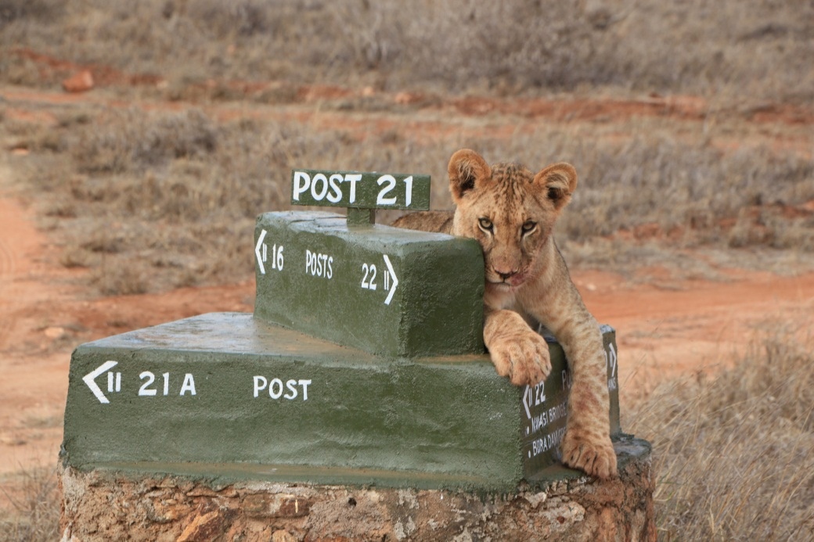

DAY 6
06:30 – 08:30 - Last game drive on our program whereby you will the taken out to enjoy the morning beauty of Ol Pejeta Conservancy. Perhaps a last glimpse of a lion, cheetah, leopard or hyena will do it for you. Perhaps elephants grazing in the morning sunlight or gazelles or zebras, this will be a very relaxed game drive to ensure you have the most pleasant time. After that, you shall be taken back to the camp for a hot breakfast.
08:30-10:00- Between this time, you are expected to have your breakfast, pack your luggage and check out from your tent. The driver will also load the luggage in the van and prepare for the journey back to Nairobi.
10:00 – Onwards - We shall aim to depart from Ol Pejeta Conservancy at this time and start our journey back to Nairobi, which will be approximately 3 – 4 hrs and we aim to make it in Nairobi in time for lunch at your hotel. This will be our final part of our program.

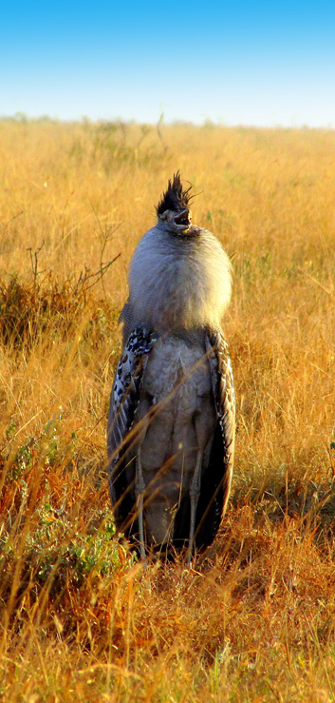
WHAT TO TAKE:

- SUN PROTECTION CREAM
- HAT/CAP
- SUN GLASSES
- ANTI MOSQUITO/INSECT REPELLANT
- COMFORTABLE, LIGHT CLOTHES AND SHOES
- LONG SLEEVE TROUSERS AND JACKET FOR EARLY MORNING AND EVENING DRIVES
- CAMERA
- SPARE BATTERIES
- BINOCULARS

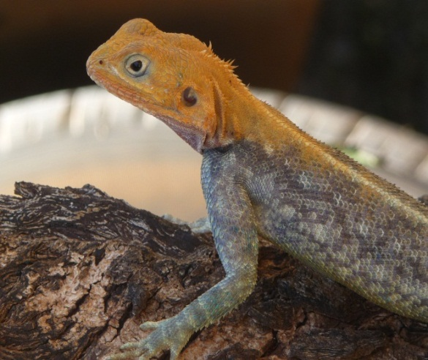
PRICE INCLUDES:
- PARK FEE
- TRANSPORT IN A MINI VAN WITH
A POP-UP ROOF FROM AND BACK TO
THE HOTEL
- DRIVER-GUIDE ASSISTANCE
- WATER IN THE CAR 0,5 L. PER PERSON
- BUFFET LUNCH IN THE HOTEL

info@costotours.com +254 704 135 984

